**ZERO TOLERANCE PRACTICE POLICY**

## Document Control

### A. Confidentiality Notice

This document and the information contained therein is the property of The Pine Medical Centre.

This document contains information that is privileged, confidential or otherwise protected from disclosure. It must not be used by, or its contents reproduced or otherwise copied or disclosed without the prior consent in writing from The Pine Medical Centre.

### B. Document Details

|  |  |
| --- | --- |
| **Classification:** | Patients / Visitors |
| **Author and Role:** | Paula Kayser |
| **Organisation:** | Pine Medical Centre |
| **Document Reference:** | BC/PK |
| **Current Version Number:** | 1 |
| **Current Document Approved By:** | P Kayser |
| **Date Approved:** | 01.08.21 |
| **Review Date** | 28/09/2023 |

### C. Document Revision and Approval History

|  |  |  |  |  |
| --- | --- | --- | --- | --- |
| **Version** | **Date** | **Version Created By:** | **Version Approved By:** | **Comments** |
| 1 | 01.08.21 | PK | PK |  |
| 2 | 28/09/2022 | PK | Pk |  |
|  |  |  |  |  |
|  |  |  |  |  |
|  |  |  |  |  |
|  |  |  |  |  |
|  |  |  |  |  |
|  |  |  |  |  |
|  |  |  |  |  |
|  |  |  |  |  |

**INTRODUCTION**

The Practice takes it very seriously if a member of staff is treated in an abusive or violent way.

The Practice supports the government's 'Zero Tolerance' campaign for Health Service Staff. This states that GPs and their staff have a right to care for others without fear of being attacked or abused. To successfully provide these services a mutual respect between all the staff and patients has to be in place.

Our Practice staff aim to be polite, helpful, and sensitive to all patients’ individual needs and circumstances. They would respectfully remind patients that very often staff could be confronted with a multitude of varying and sometimes difficult tasks and situations, all at the same time. The staff understand that ill patients do not always act in a reasonable manner and will take this into consideration when trying to deal with a misunderstanding or complaint.

However, aggressive behaviour, be it violent or abusive, will not be tolerated and may result in you being removed from the Practice list and, in extreme cases, the Police being contacted.

In order for the practice to maintain good relations with their patients the practice would like to ask all its patients to read and take note of the occasional types of behaviour that would be found unacceptable:

* Using bad language or swearing at practice staff
* Any physical violence towards any member of the Primary Health Care Team or other patients, such as pushing or shoving
* Verbal abuse towards the staff in any form including verbally insulting the staff
* Racial abuse and sexual harassment will not be tolerated within this practice
* Persistent or unrealistic demands that cause stress to staff will not be accepted. Requests will be met wherever possible and explanations given when they cannot
* Causing damage/stealing from the Practice's premises, staff or patients
* Obtaining drugs and/or medical services fraudulently
* We ask you to treat your GPs and their staff courteously at all times.

The Legal Position

As a responsible employer, the Practice has a duty as a provider of NHS healthcare to protect the health, safety and welfare of staff under the Health & Safety at Work Act. This includes a risk assessment of violence towards staff and taking steps to mitigate this under the Management of Health and Safety at Work Regulations 1999.

Staff members who are victims of violent conduct or assault have the right to sue their employers for compensation if the risk of violence could have been reduced or removed completely, but the employers did not act upon this information.

Examples of security issues:

* Security of grounds and car parking
* Security of premises – incl. storage, “out of hours”
* CCTV
* Cash and staff - storing, handling and transferring
* Security Systems
* Security of equipment – medical devices, computers
* Communication of national security alerts
* Information records
* Contingency planning.
* Security of employees
* Staff working on their own
* (Staff can be lone workers when making domiciliary visits or within a hospital department e.g. out of hours)

This list is not exhaustive.

For example a lone working risk assessment must provide the lone worker full knowledge of the hazards and risks to which he or she is being exposed and what they must need to do will something go wrong. Other responsible persons must know the whereabouts of lone workers and what they are doing;

Violence at Work

The practice acknowledges that there may be instances where violence and / or aggression forms part of a patient’s illness. In these circumstances, the issue will be discussed with the patient and form part of their care planning.

This information will be recorded in the patient’s medical record and flagged to ensure that members of staff are aware. In addition, where deemed necessary, appropriate support will be put in place, e.g. staff members do not see the patient alone.

## Definition of Physical and Verbal Abuse and Violence:

### Physical and verbal abuse includes:

* Unreasonable and / or offensive remarks or behaviour / rude gestures / innuendoes
* Sexual and racial harassment
* Threatening behaviour (with or without a weapon)
* Actual physical assault (whether or not it results in actual injury) includes being pushed or shoved as well as being hit, punched or attacked with a weapon, or being intentionally struck with bodily fluids or excrement.
* Attacks on partners, members of staff or the public
* Discrimination of any kind
* Damage to an employee's or employer's property

### The Practice supports the Zero Tolerance stance adopted by the NHS.

### The HSE (Health and Safety Executive) defines work-related violence as:

*"Any incident, in which a person is abused, threatened or assaulted in circumstances relating to their work".*

### Violence and aggression towards a person may also be defined as:

*"A physical contact with another person which may or may not result in pain or injury. The contact is uninvited and is an attempt to cause harm, injury or to intimidate. Non-physical aggression includes the use of language which causes offence or threatens the safety of a member of staff".*

### Under the Health and Safety at Work Act 1974, the practice will also undertake the following measures to ensure a safe work environment:

* Carry our risk assessments to assess and review the duties of employees, identifying any "at risk" situations and taking appropriate steps to reduce or remove the risk to employees, particularly if they are working alone.
* Assess and review the layout of the premises to reduce the risk to employees where physically possible.
* Assess and review the provision of personal safety equipment, such as alarms.
* Develop surgery policies, procedures and guidelines for dealing with physical and verbal abuse.
* Provide support and counselling for victims, or refer to suitably qualified health professionals.
* Make employees aware of risks and ensure employee involvement in suitable training courses.
* Record any incidents on a Significant Event form and take any remedial action to ensure similar incidents are prevented in future.

REMOVAL FROM THE PRACTICE LIST

The removal of patients from our list is an exceptional and rare event and is a last resort in an impaired patient-practice relationship. We value and respect good patient-doctor relationships based on mutual respect and trust. When trust has irretrievably broken down, the practice will consider all factors before removing a patient from their list, and communicate to them that it

is in the patient’s best interest that they should find a new practice. An exception to this is in the case of immediate removal on the grounds of violence e.g. when the Police are involved.

Removing other members of the household

Because of the possible need to visit patients at home, it may be necessary to terminate responsibility for other members of the family or the entire household to ensure the safety of practice staff.

The prospect of visiting patients that is the residence of a relative who is no longer a patient of the practice, or the risk of being regularly confronted by the removed patient, may make it difficult for the practice to continue to look after the whole family. This is more likely where the removed patient has been violent or displayed threatening behaviour, and keeping the other family members could put doctors or their staff at risk.

Zero Tolerance Poster

Zero Tolerance Posters have been made available from CCGs for use in practices and NHS healthcare providers premises.

The poster on the following page can be used and resized in another template or a blank page and displayed in practice.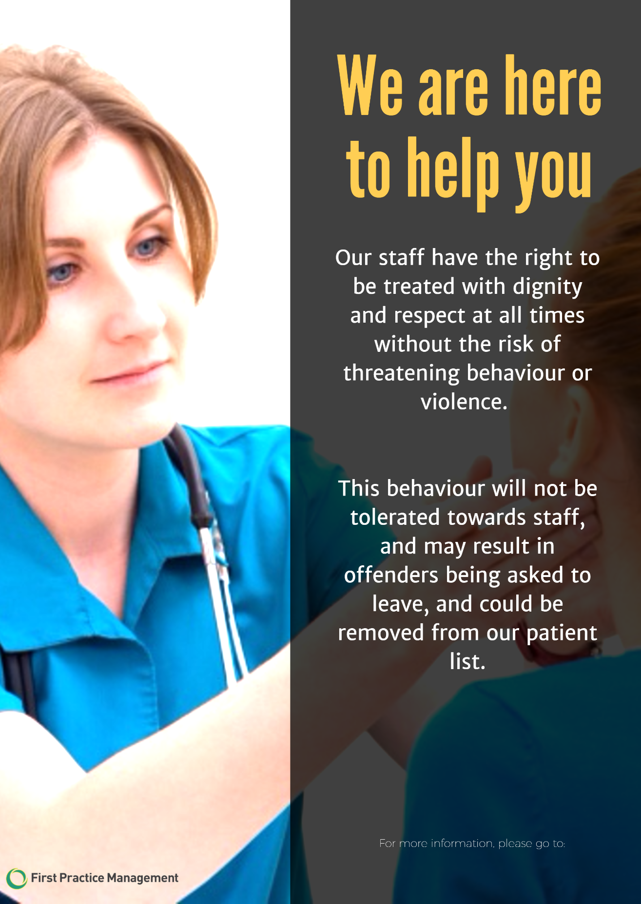

**The Pine Medical Centre**

**APPENDIX 1 : EXAMPLE TEMPLATE LETTER TO PATIENT**

Recipient’s Name

Address Line 1

Address Line 2

Town Postcode

Dear [Mr/Mrs/Ms XXX]

**Re: XXXX**

I am writing to you about an alleged event / incident on **\*\*\*INSERT DATE HERE\*\*\*** at **\*\*\*INSERT**

**ADDRESS HERE\*\*\*** where the following occurred;

**\*\*\*INSERT DESCRIPTION OF INCIDENT HERE\*\*\***

The practice views this behaviour as unacceptable because **\*\*\*INSERT HERE\*\*\***.

If you disagree with this description of what occurred, or there are circumstances that we are unaware of, which you believe would help explain what happened then please let us know (preferably in writing) as soon as possible.

If you would like to discuss this matter, please contact us to arrange a meeting at a time that is mutually convenient to discuss these concerns.

As a provider of NHS primary care services to the community, ***INSERT PRACTICE NAME HERE*** have a Zero Tolerance Policy for dealing with situations where our staff or services are abused.

Our policy is available to read on our website **\*\*\*INSERT WEBLINK HERE\*\*\***.

Such cases will be reported to the practice manager and discussed with a senior GP at the earliest opportunity to decide on the appropriate actions, which include;

* Sending of warning letter
* Removal from the practice list
* Reporting to police

Where there is serious or persistent misbehaviour it can result in the patient being removed from our practice list. Before taking any such action we would like to hear from you to understand why the above incident has occurred.

Please remember that we, as healthcare providers, are here to help you and other patients get the services they require. All we ask is that our patients act in a reasonable manner and considerate of the demands they make of us.

A copy of this letter will be kept on file. Please find enclosed a copy of our complaints leaflet for your information.

Yours sincerely

**Name(s)**

**Title**

**APPENDIX 2 : EXAMPLE TEMPLATE LETTER TO PATIENT – REPEATED BEHAVIOUR**

Recipient’s Name

Address Line 1

Address Line 2

Town

Postcode

Dear [Mr/Mrs/Ms XXX]

**Re: XXXX**

I am writing to you about an alleged event / incident on **\*\*\*INSERT DATE HERE\*\*\*** at **\*\*\*INSERT ADDRESS HERE\*\*\*** where the following occurred;

**\*\*\*INSERT DESCRIPTION OF INCIDENT HERE\*\*\***

The practice views this behaviour as unacceptable because **\*\*\*INSERT HERE\*\*\***.

We have written to you previously on **\*\*\*INSERT DATE HERE\*\*\*** and warned on that occasion of our Zero Tolerance Policy on serious or persistent misbehaviour, which can result in patients being removed from our practice list. Before taking any such action we would like to hear from you to understand why the above incident has occurred.

If we do not receive a response from you by **\*\*\*INSERT DATE HERE\*\*\*** we may decide to notify the NHS England to have you removed from our list.

Please remember that we are here to help you. All we ask is that our patients act reasonably and are considerate in the demands they make of us.

Yours sincerely

**Name(s)**

**Title**

**APPENDIX 3 : TEMPLATE LETTER TO PATIENT – REMOVED FROM PRACTICE LIST**

Recipient’s Name

Address Line 1

Address Line 2

TOWN

Postcode

Dear [Mr/Mrs/Ms XXXXX]

Re: XXXXXX

Further to my letter of **\*\*\*INSERT DATE HERE\*\*\***, copy enclosed for information, I am writing to you about the incident/situation* on (date) at (time) and (place) when …....... (describe)….... occurred.

We have investigated this incident and after due consideration, we have taken the decision to ask the NHS England to have you removed from our patient list. This is because we feel that

***INSERT AS APPROPRIATE***

Situations that justify removal from our patient list;

* Violent/aggressive behaviour
* Criminal acts/deception
* Distance/outside designated practice area
* Failure to attend appointments
* Breakdown of Doctor/Patient relationship

NHS England will be in touch with you in due course about finding another practice with which you can register.

**\*\*\*ATTACH PRACTICE COMPLAINTS LEAFLET OR WEBLINK IF THIS IS ON PRACTICE WEBSITE\*\*\***

Yours sincerely

**Name(s)**

**Title**